Mongo Connector set up in studio.
- Install Mongo connector via extension. In the extension window please locate the mongo connector and click install.
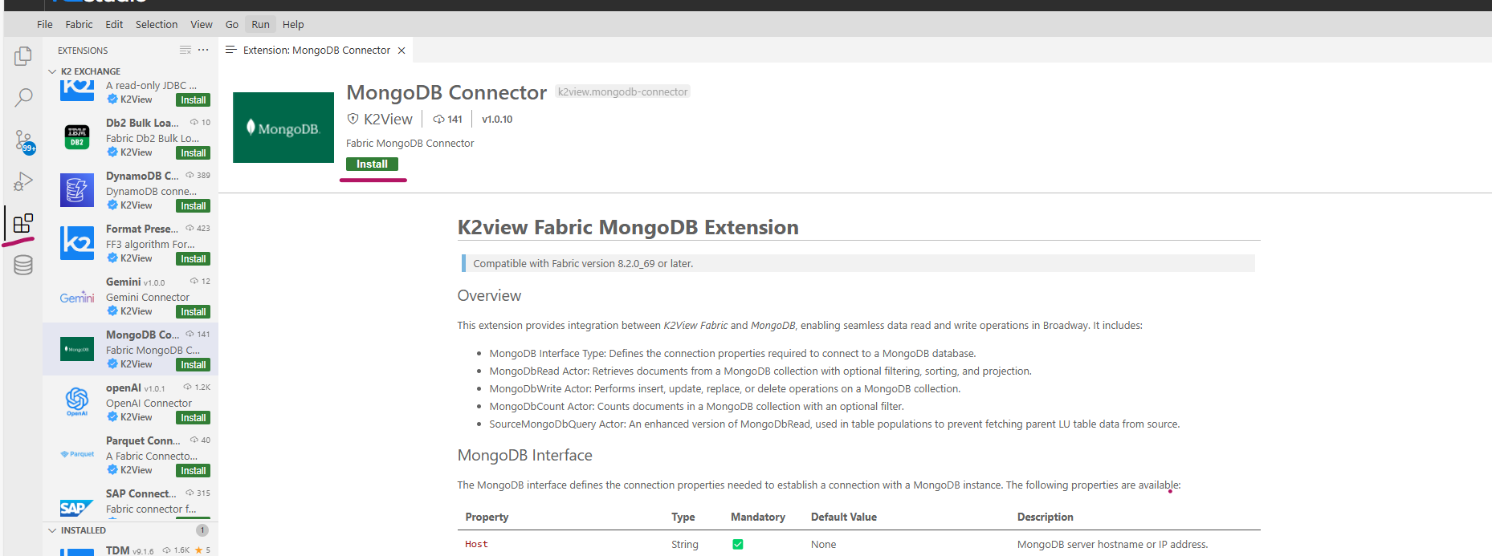

- After successful installation it will import 27 files to your project tree.
- After installation please verify under Shared Object->Broadway->MongoDB is created as shown below
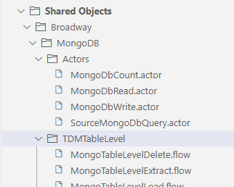

- Connecting to Mongodb
  - Under shared objects - > Intefaces. Right click on Interfaces and click on New Interface..
  - 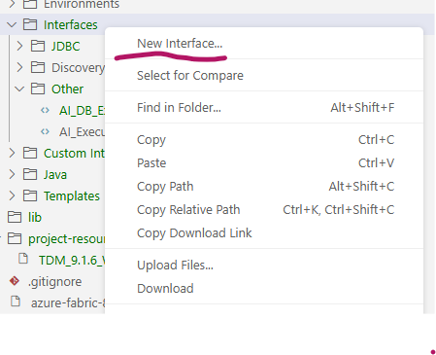
  - A new interface window will appear
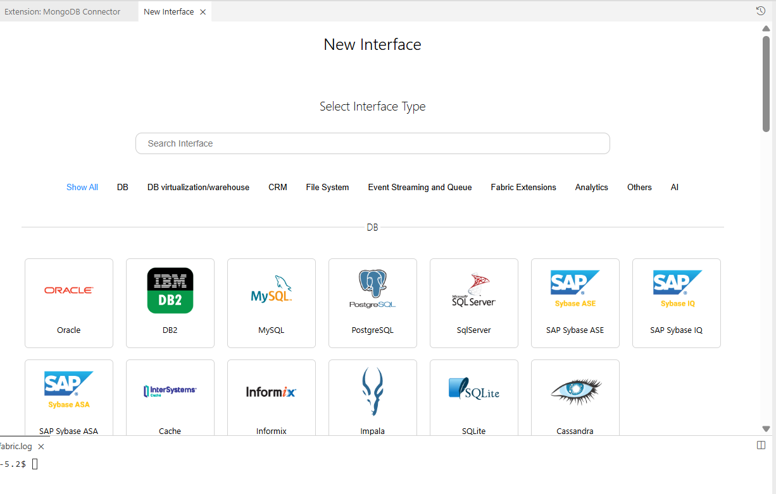
  - In the Select Interface Type please search for MongoDB. Below window will appear.
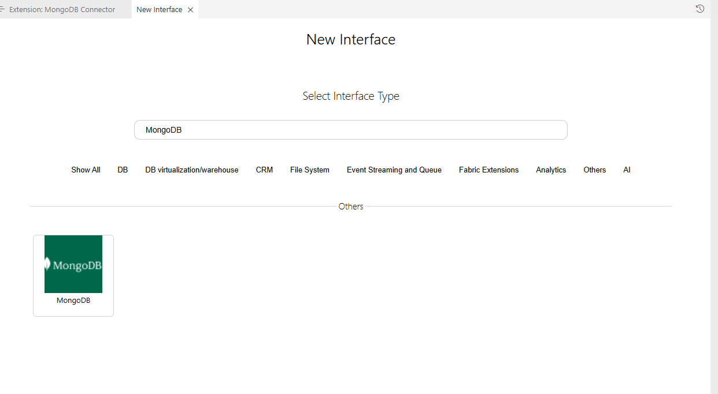
Click on MongoDB and then in the next window please provide the appropriate MongoDB name of your choice and Click on create.
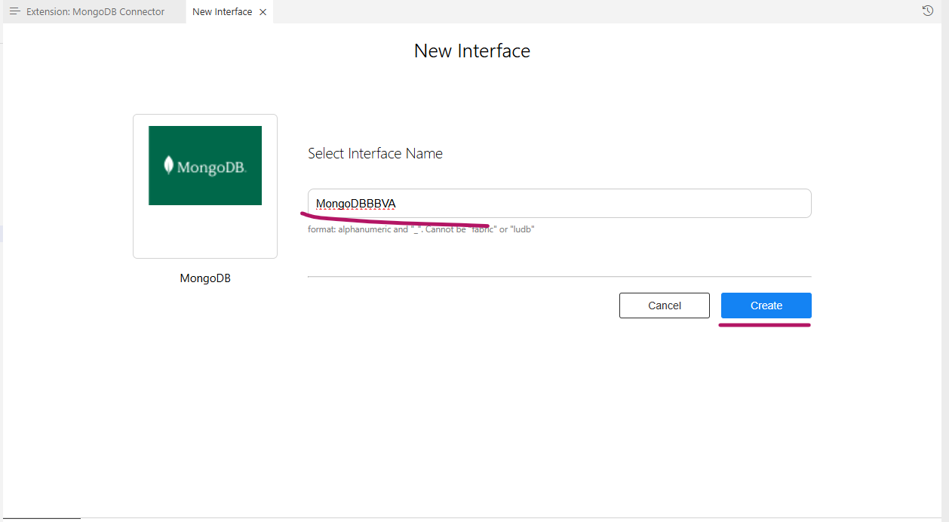
Please provide the details for the mongo interface..
Note : Uncheck SSLEnabled.
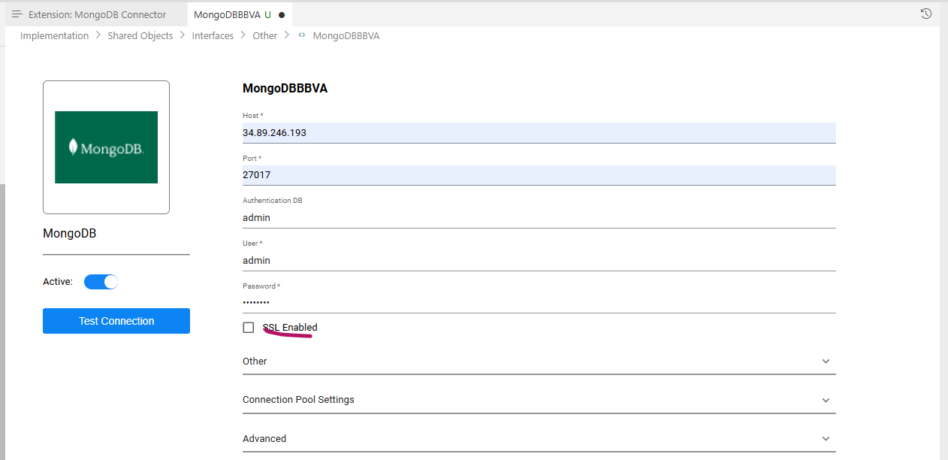
And do the test connection.

Running discovery job on Mongo:
After TDM 9.1.3, plugin_discovery is removed and instead we need to use discovery_pipeline in the catalog page under setting tab. This will imply to all kind of intefaces.
And we should add the rule to include needed collections/schemas as shown below:
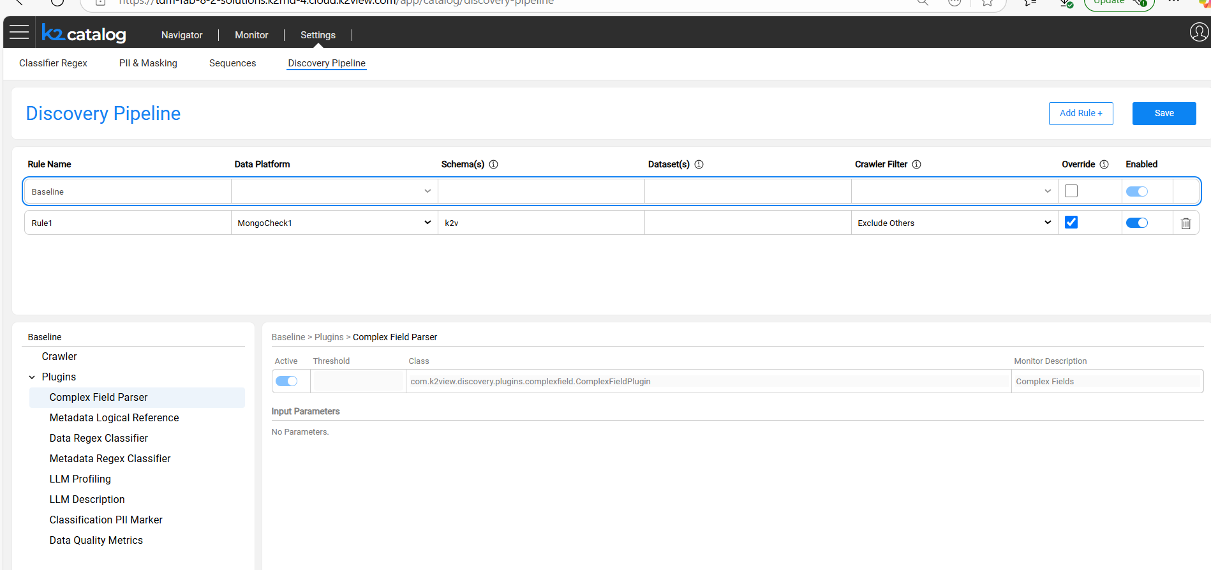

Rule Name : Add appropriate name
Data Platform : IntefaceName
Schema: name of schemas you need to include/exclude
Datasets – Any specific table that needs to include/exclude
Crawler Filter – Exclude others – it will include the schema and table which is mentioned in the row.
Override – select the check box
Enabled – Enable – to enable the rule
After writing the rule please click save button.
Once it is saved please go Intefaces->Other-> created mongo db. Right click on the created mongo db and run the discovery job
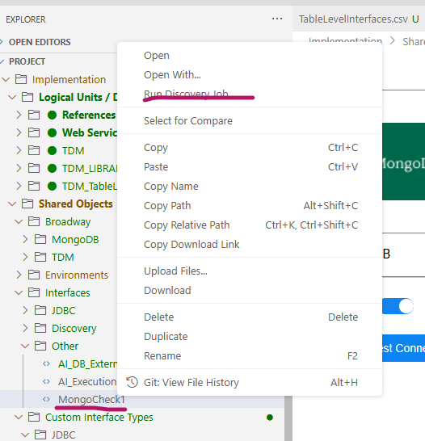

After running the discovery job you will see the catalog version with only selected schema.
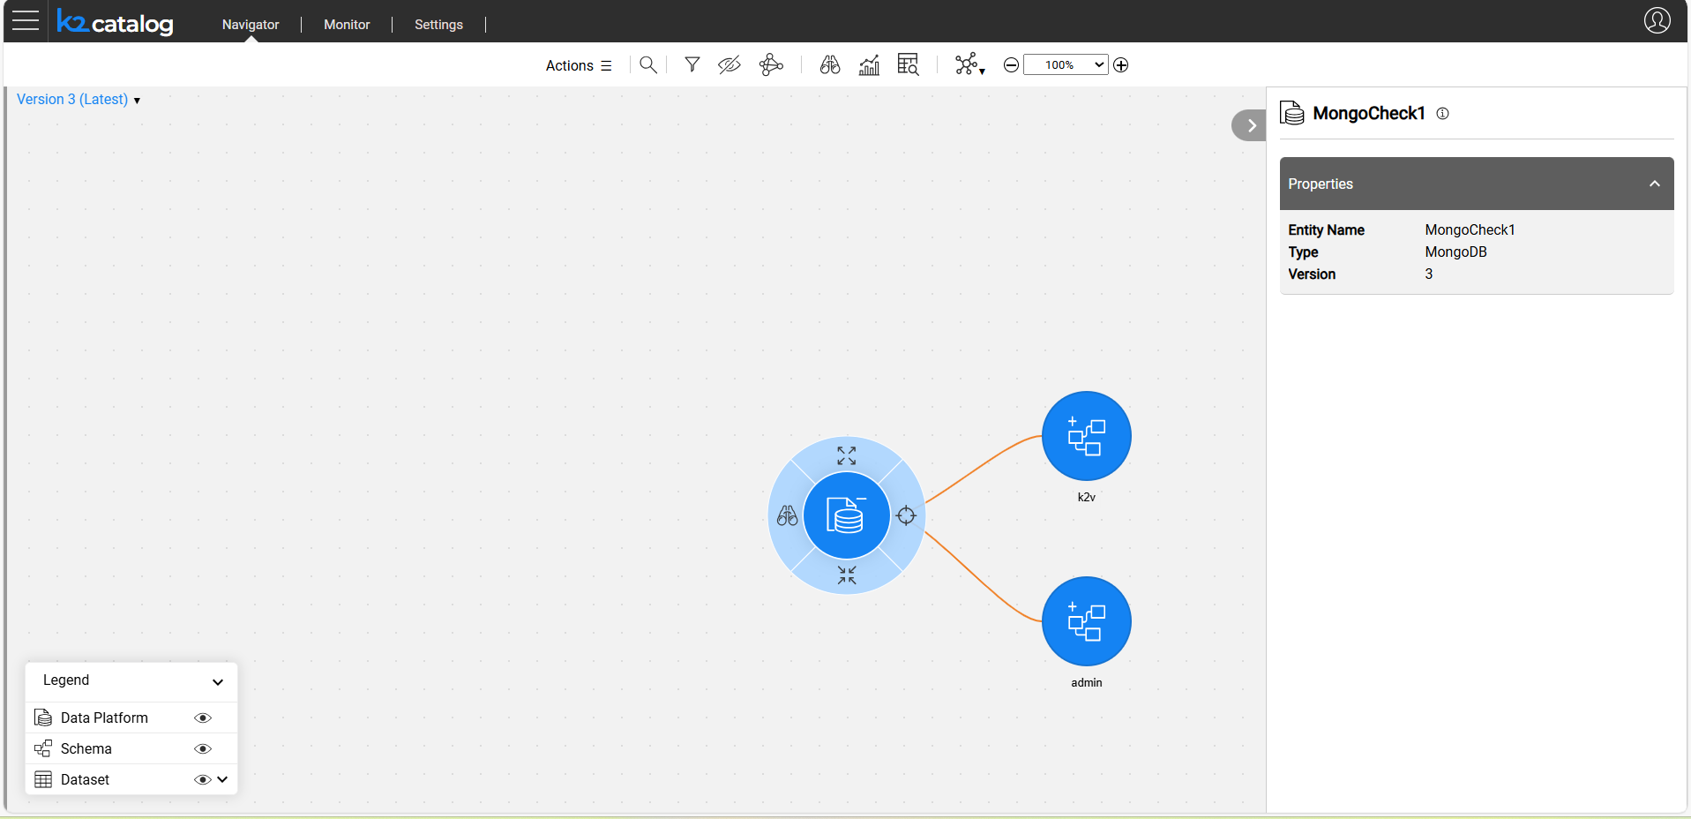

Now build the artifacts.
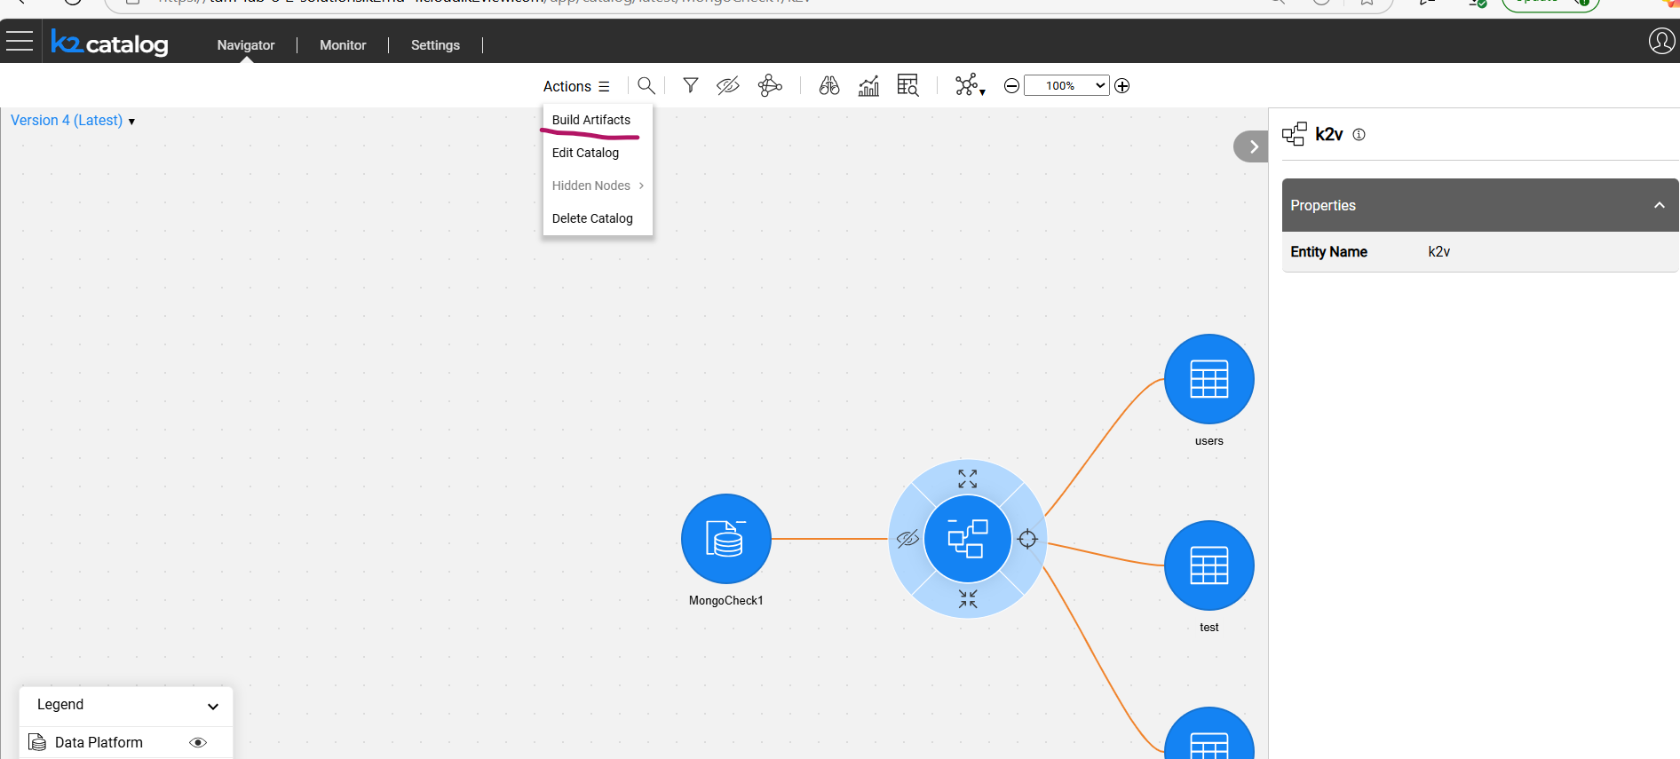

Deploy the TDM LU.
Creating the table_level extract task.
In TDM gui click on new task:
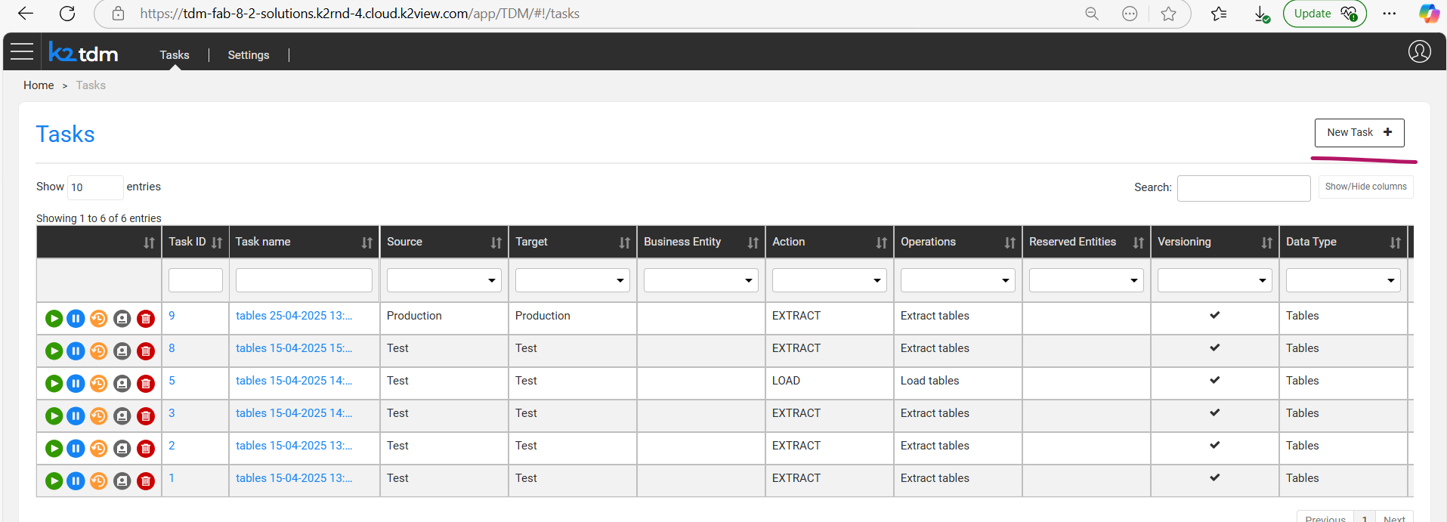
Give the task name and description
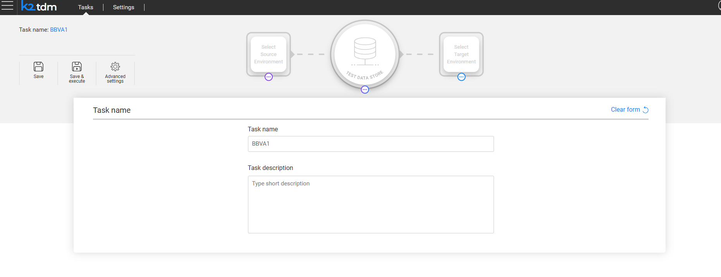
Click Select Source Environment.
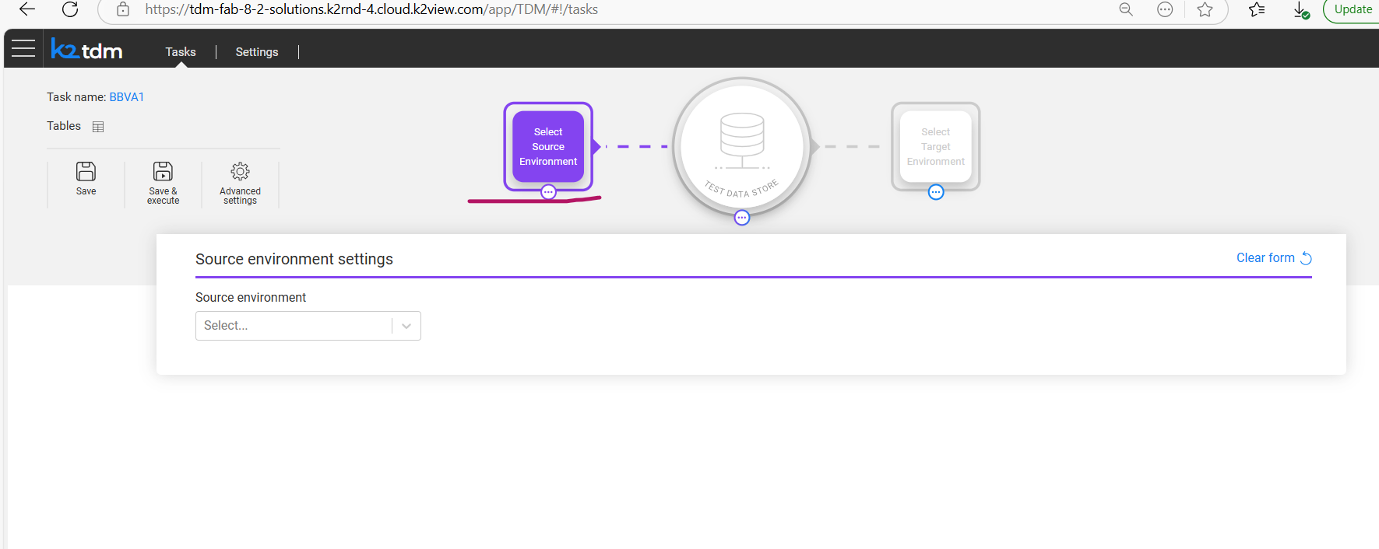
Select your appropriate environment
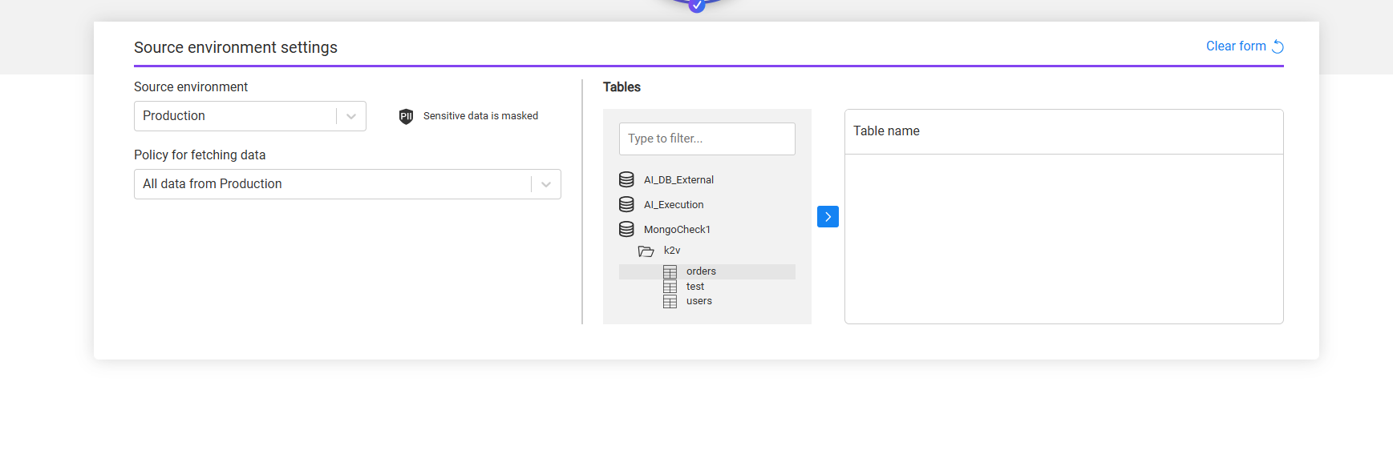
Select the table you want to extract/load.
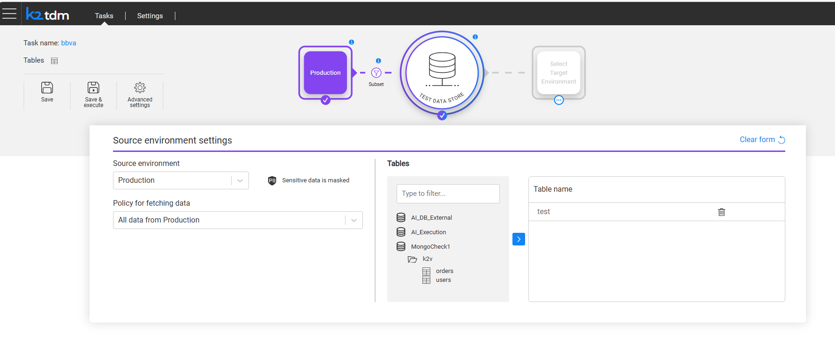

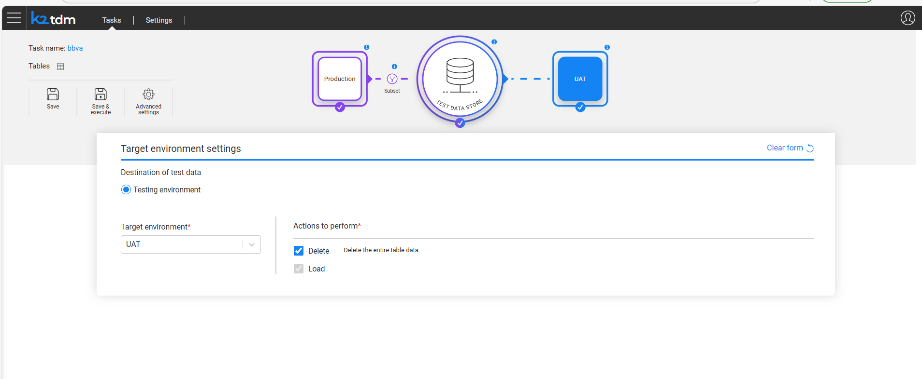
Save the task and DO NOT execute yet.
Now to run the Mongo DB table level extract, load and delete, customized flow needs to be configured.

Once you installed MongoDB connector, you will see the file TableLevelDefinitions___mongodb.csv in References->Mtable.
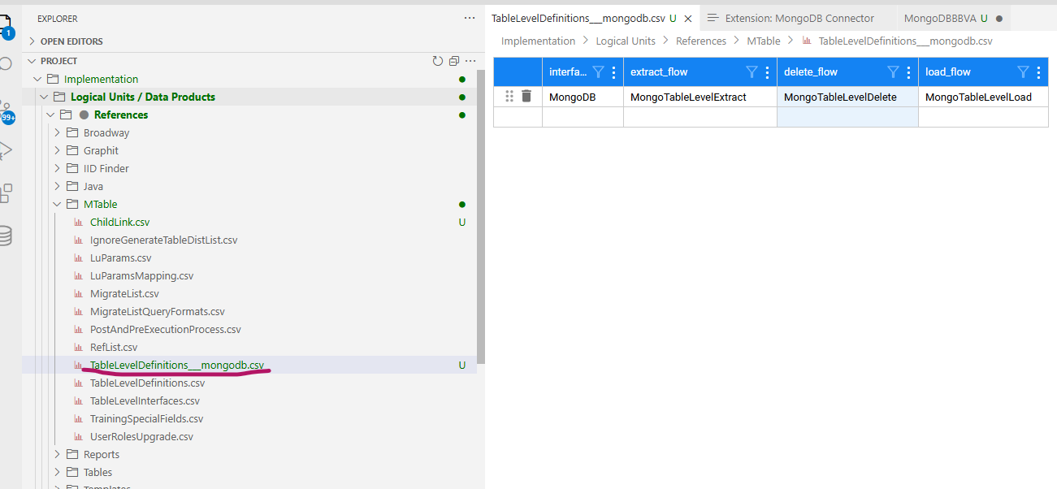

We need to update data present in this file into the TableLevelDefinitions.csv as below:

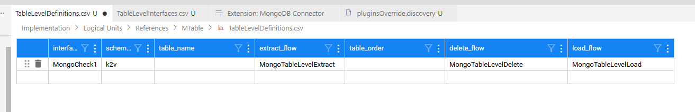

Please save TableLevelDefinitions.csv after the update and deploy the references LU.

Now in TDM gui please run the task.
Additional information to validate the Mongo Table level extract/load/delete after the task execution
Note the task execution id:
In my example it is 16
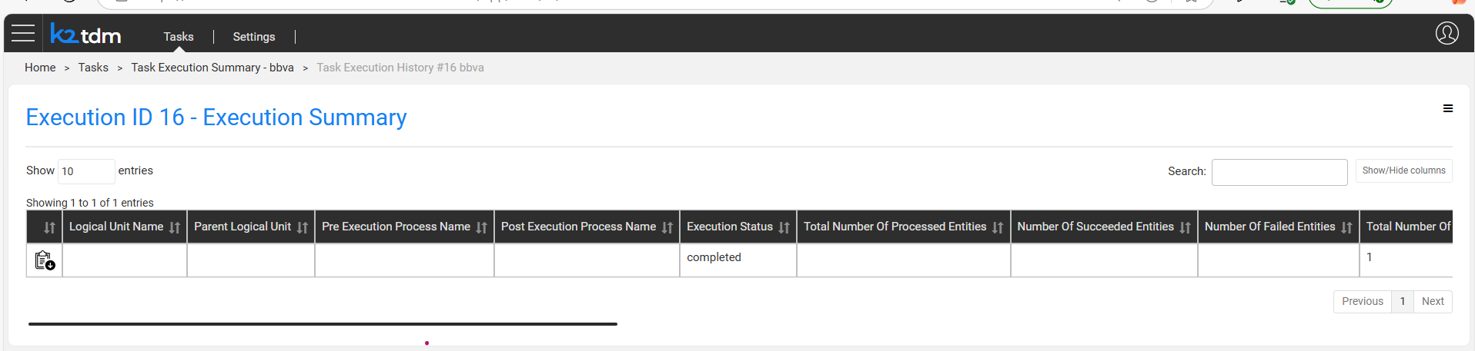

Go to tdm and run
select * from public.task_execution_entities
schema may by public or whatever is created in your space.

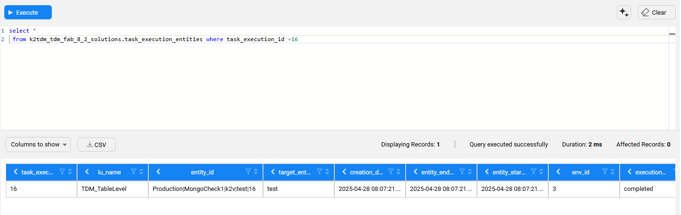
Select the entity id from here : in my case : Production|MongoCheck1|k2v|test|16
Go to fabric query builder
Select Mode : Synce Force
Lu : TDM_TableLevel
Entity id : Production|MongoCheck1|k2v|test|16
And give the sql statement as
select * from TDM_TableLevel.TDM_REF_ROOT
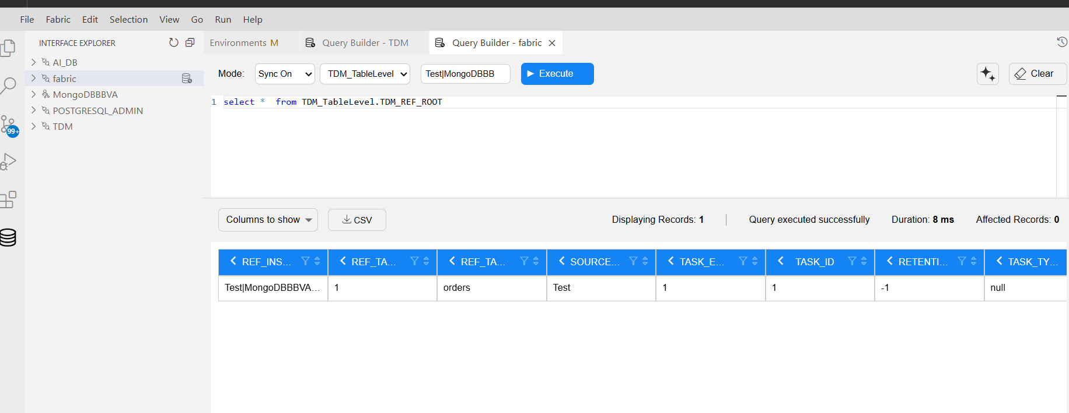
Then run /*sqlite*/ select * from __t_{give_your_tableName}
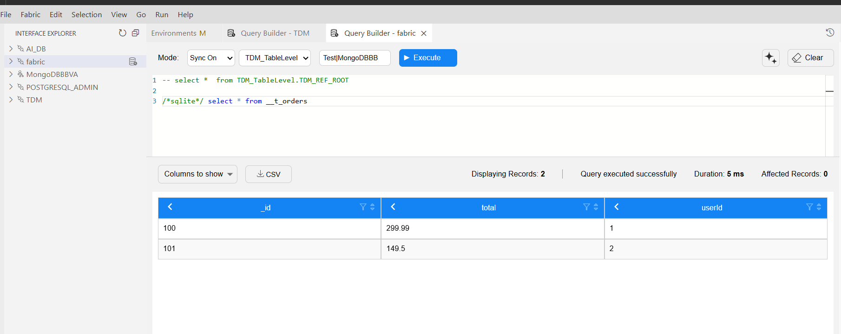
Make sure you coment the query -- select * from TDM_TableLevel.TDM_REF_ROOT

This is the process to see the table level data.

